**LABORATORY EQUIPMENT REQUEST FOR RESEARCH AND DEVELOPMENT**

**THERMODYNAMICS LABORATORY EQUIPMENT**

1. **CUSSONS P8660 Computer Controlled Multi Cylinder Engine Test Bed (ETB)**

Cussons P8660 Series Computer Controlled Multi-Cylinder Automotive Engine Test Beds have been developed to provide a self-contained advanced engine test facility for automotive and industrial light duty multi-cylinder engines having full **AUTOTEST IV** computer control and data management system purpose designed for engine performance, economy and energy balance measurements. With suitable ancillary equipment, as specified in subsequent items, the system can be used for data logging, exhaust emissions analysis work and high speed combustion data acquisition programmes.

**Experimental Capabilities and Measurements**

 Measurement of maximum torque and maximum power with plotting of full throttle/rack power against speed curve

 Determination of brake mean effective pressures

 Analysis of torque speed characteristics

 Determination of fuel consumption characteristics

 Calculation of brake specific fuel consumptions

 Analysis of load characteristics at constant speed

 Determination of volumetric efficiency

 Air consumption, fuel consumption, air/fuel ratios

 Brake thermal efficiencies

 Exhaust, water, oil and air temperatures

 Pressure/time, pressure/volume and crank angle diagrams (with P4600/P4605)

**Dynamometer requirements:**

**P8661 COMPUTER CONTROLLED MULTI-CYLINDERETB WITH  HYDROKINETIC DYNAMOMETER.**

**P8662 COMPUTER CONTROLLED MULTI-CYLINDERETB WITH EDDY CURRENT DYNAMOMETER.**

**P8663 COMPUTER CONTROLLED MULTI-CYLINDERETB WITH REGENERATIVE DYNAMOMETER**

**AUTOTEST IV SPECIFICATION**: the main configurations as standard are:-

 64 Analogue input channels

 16 Analogue output channels

 64 Digital input channels

 32 Digital (relay) output channels

 16 Frequency input channels

 A 2 channel hardware in-cell display and manual control unit

 Operator display via single screen PC

**Experimental Capabilities and Measurements Equipment Requirements**

**P8634 Dynamometer calibration equipment**

**P8635 Installation materials kit suitable for P8651, P8652 and P8653**

**P8613 Four Cylinder Water Cooled Spark Ignited Engine**

**P8621 Four Cylinder Water Cooled Compression Ignition Engine**

**P8263 Exhaust Gas Calorimeter**

**P4650 Electronic Engine Indicating Equipment**

**P4651 PC & Printer**

**P4652 Combustion Analysis Software**

**P4650 Electronic Engine indicating Kit**

**P8390 Basic Emission Analyser for HC—CO—CO2—O2**

It combines micro processor simplicity of operation with infrared sensor accuracy. The system is designed to meet or exceed the OIML class 1 specification for automotive gas analysers, and is the latest development from a proven range of analysis equipment.

**Required Equipment Accessories:**

**P8391 Oil temperature and RPM inductive pickup**

**P8392 Self calibration module including 1 gas bottle**

**P8394 Analyser Stand**

**P8395 A4 Printer**

Emission Analyser for above ETB’s

**P4651 PC & Printer**

**P4652 Software for Combustion Analysis**

**Required Equipment Accessories for Diesel Engines**

P4426 Strain Gauge Pressure Transducer & Adaptor

P4447 Strain Gauge Amplifier Channel

P4427 Standard Injector Needle Lift Transducer & Injector

P4444 Amplifier Channel for Injector Needle Lift

**Required Equipment Accessories for Gasoline Engines**

Piezo Transducer Spark Plug Adaptor

**Injection Timing Module**

1. **Gas and Bomb Calorimeters**

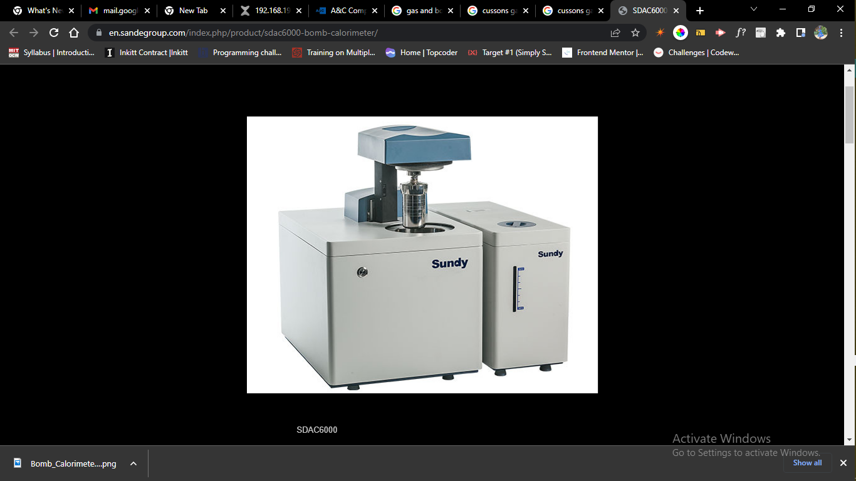

SDAC6000 Bomb Calorimeter

**Application:**

1. SDAC6000 automatic isoperibol oxygen bomb calorimeter can be used to determine the calorific value in solid and liquid combustibles such as coal,coke,petroleum oil, cement black meal, biomass fuels as well as building material.
2. Fully automatic oxygen filling and releasing, fully automatic bomb raising and lowering, full test …
3. Support stand: vertical type

**Specifications:**

|  |  |
| --- | --- |
| **Description** | **SDAC6000** |
| Analysis Time | Analysis Time: <8min Full Test Process: <10min |
| Temperature Resolution | 0.0001K |
| Precision(RSD) (1g Benzoic Acid) | ≤0.05% |
| Heat Capacity Stability | ≤0.2% within three months |
| System Structure | Benchtop / Vertical |
| Conformance with Standard | ISO 1928, ISO 9831,ISO18125,ASTM D5865, ASTM D240, ASTM D4809, ASTM E711, ASTM D5468,GB/T 213,GB/T 30727, AS 1038.5，BS EN 15400, BIS1350 |
| Test per Hour | 6 |
| Bomb volume | 250ml |
| Calorimeter Type | Isoperibol |
| Oxygen Filling | Fully automatic oxygen filling & releasing, fully automatic bomb raising & lowering |
| Bomb Washing | Manual |
| Max. Bomb pressure | 20Mp |
| Bomb Identity | Yes |
| Gas Requirement | 99.5% Oxygen |
| Water Requirement | Distilled  Water |
| Energy Measurement Range | 0~50000J |
| Bucket Filling | Automatic |
| Constant Volumetric Tank with Temp Control Device | Bucket determine water volume automatically |
| Independent Bucket and Jacket Water System | Yes |
| Stirring Method | Propeller |
| Power Inverter | No |
| Reproducibility based on analysis of 1g Benzoic Acid | 0.10% |
| Average Temperature Increase | 2℃ |
| Temperature Measurement | PT1000 |
| Working Temperatures | ≤32℃ |
| Cooling method | Refrigerating Device |
| Network | Yes |
| Power | AC 220V (-10% +10%)50/60Hz |
| Max.Power | 0.6KW |
| Dimension | Main body: 428*565*485 Water tank: 220*565*410 |
| Weight | 50kg |
| Advance Calculation | Yes |
| Analysis Report | Yes |
| Statistics Report | Yes |
| System Monitor | Yes |

1. Gas and Steam Turbine Apparatus
2. Turbine Apparatus

**MATERIALS SCIENCE & METALLURGY LABORATORY EQUIPMENT**

1. High power Metallurgical Microscope with Camera unit

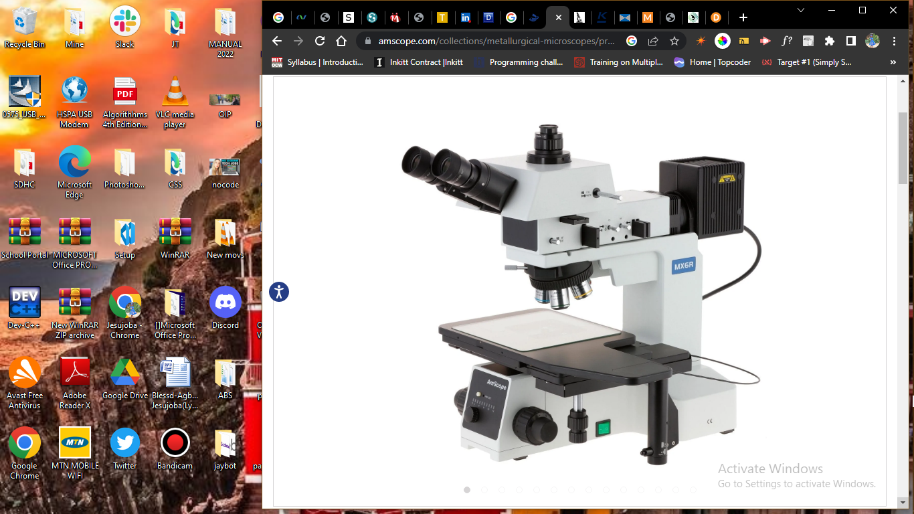

[Skip to Content](https://amscope.com/collections/metallurgical-microscopes/products/c-me600tz?variant=40841859661999" \l "acsbContent)

[↵ENTER](https://amscope.com/collections/metallurgical-microscopes/products/c-me600tz?variant=40841859661999" \l "acsbContent)

[Skip to content](https://amscope.com/collections/metallurgical-microscopes/products/c-me600tz?variant=40841859661999#MainContent)

0

[[https://cdn.shopify.com/s/files/1/0526/7285/6239/files/thumbnail_Clearance-sale-60off-US-top-ad_300x.jpg?v=1672993653](https://amscope.com/collections/blowout-clearance-sale-up-to-60-off)](https://amscope.com/collections/blowout-clearance-sale-up-to-60-off)

1. [Home](https://amscope.com/) /
2. [Metallurgical Microscopes](https://amscope.com/collections/metallurgical-microscopes) /
3. Large-Format Stage Trinocular Brightfield and Polarizing Metallurgical Microscope w/Additional 100X Objective Lens and Optional Digital Camera



50X-2500X Large-format Trinocular Upright Metallurgical Microscope w/ 20MP USB 3.0 C-mount Camera

Top of Form

SKU: ME600TZC-20MBI3

0.0 star ratingWrite a review

QTY:

−+

ADD TO CART

AVAILABILITY: IN STOCK

Regular price~~$13,804.99~~ $11,503.99

[**>> How to Buy A Microscope**](https://amscope.com/collections/metallurgical-microscopes/products/c-me600tz?variant=40841859661999#guide)

**Magnification**

50X-1000X

50X-1500X

50X-2000X

50X-2500X

**Camera Type**

none selected

USB 2.0

USB 3.0

**Camera Pixels**

3.0MP

5.0MP

10.0MP

14.0MP

16.0MP

18.0MP

20.0MP



Bottom of Form

Key Features

* 50X to 2500X magnification with five brightfield/darkfield objective lenses and 10X and 25X eyepieces.
* Designed for manufacturing, QC, and materials analysis, this large format microscope provides multiple observation methods including brightfield, darkfield, and simple polarization.
* Extra-large stage with clutch control for coarse positioning, and precision X-Y controls for microscopic adjustments
* Five large-diameter, plan-achromatic BD objective lenses provide increased field-of-view and high resolutions.
* Use a combination of brightfield, darkfield, and simple polarization to bring out complex details such as stress in metal and other materials.
* The infinity-corrected optical system eliminates certain optical errors when using filters and other in-line components, ensuring highly-precise images.
* The trinocular head provides a dedicated photo port for adding a camera for recording photos and videos.
* Monitor and capture photos and videos with the included back-illuminated 20MP USB 3.0 camera. Professional microscopy software for Windows, Mac, and Linux provide tools for image processing, measuring, and more.

DESCRIPTION

ADDITIONAL INFO

REVIEWS

0.0 star rating0 Reviews

WRITE A REVIEW

Top of Form

Bottom of Form

Top of Form

Bottom of Form

BE THE FIRST TO WRITE A REVIEW

People Also Viewed

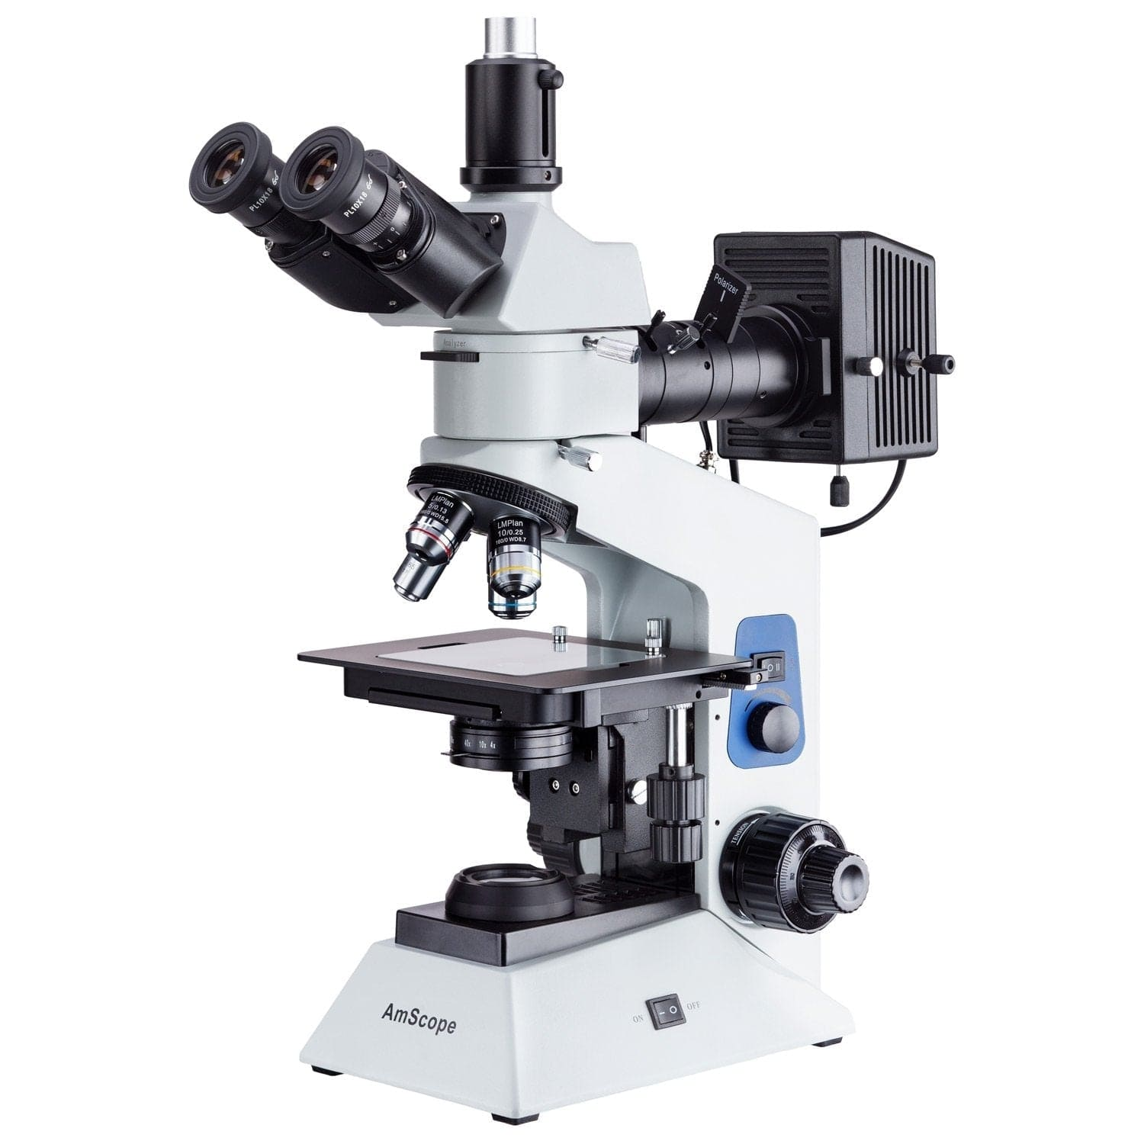

Dual Illumination Polarized Light Compact Trinocular Metallurgical Microscope w/Optional Digital Camera

Sku: ME580T-PZ-2L

~~$1,193.99~~$994.99

[VIEW PRODUCT](https://amscope.com/products/c-me580t-pz-2l?pr_prod_strat=collection_fallback&pr_rec_id=021533a00&pr_rec_pid=7083019042991&pr_ref_pid=6999684481199&pr_seq=uniform)

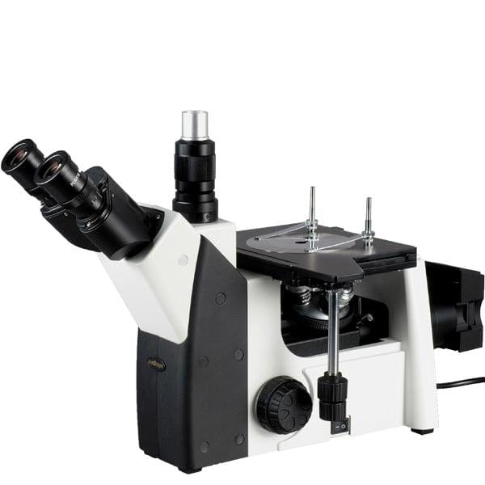

Binocular Inverted Plan Optics Metallurgical Microscope w/Optional Digital Camera

Sku: ME1200T

~~$1,993.99~~$1,661.99

[VIEW PRODUCT](https://amscope.com/products/c-me1200t?pr_prod_strat=collection_fallback&pr_rec_id=021533a00&pr_rec_pid=7083018649775&pr_ref_pid=6999684481199&pr_seq=uniform)

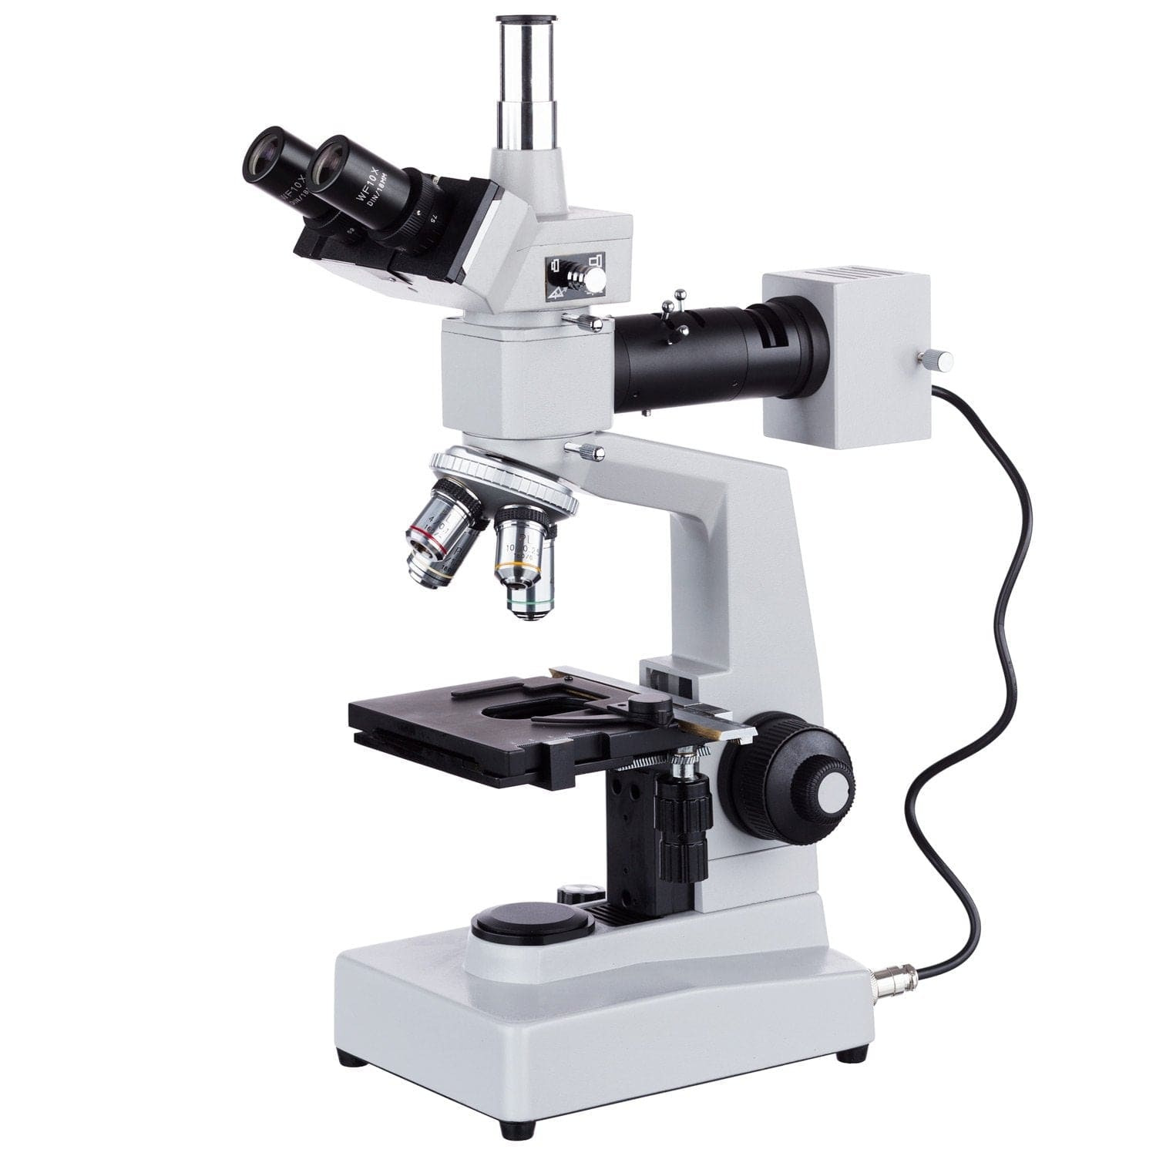

Trinocular Metallurgical Microscope

Sku: ME300TZ

~~$1,098.99~~$915.99

[VIEW PRODUCT](https://amscope.com/products/c-me300tz?pr_prod_strat=collection_fallback&pr_rec_id=021533a00&pr_rec_pid=7083018453167&pr_ref_pid=6999684481199&pr_seq=uniform)

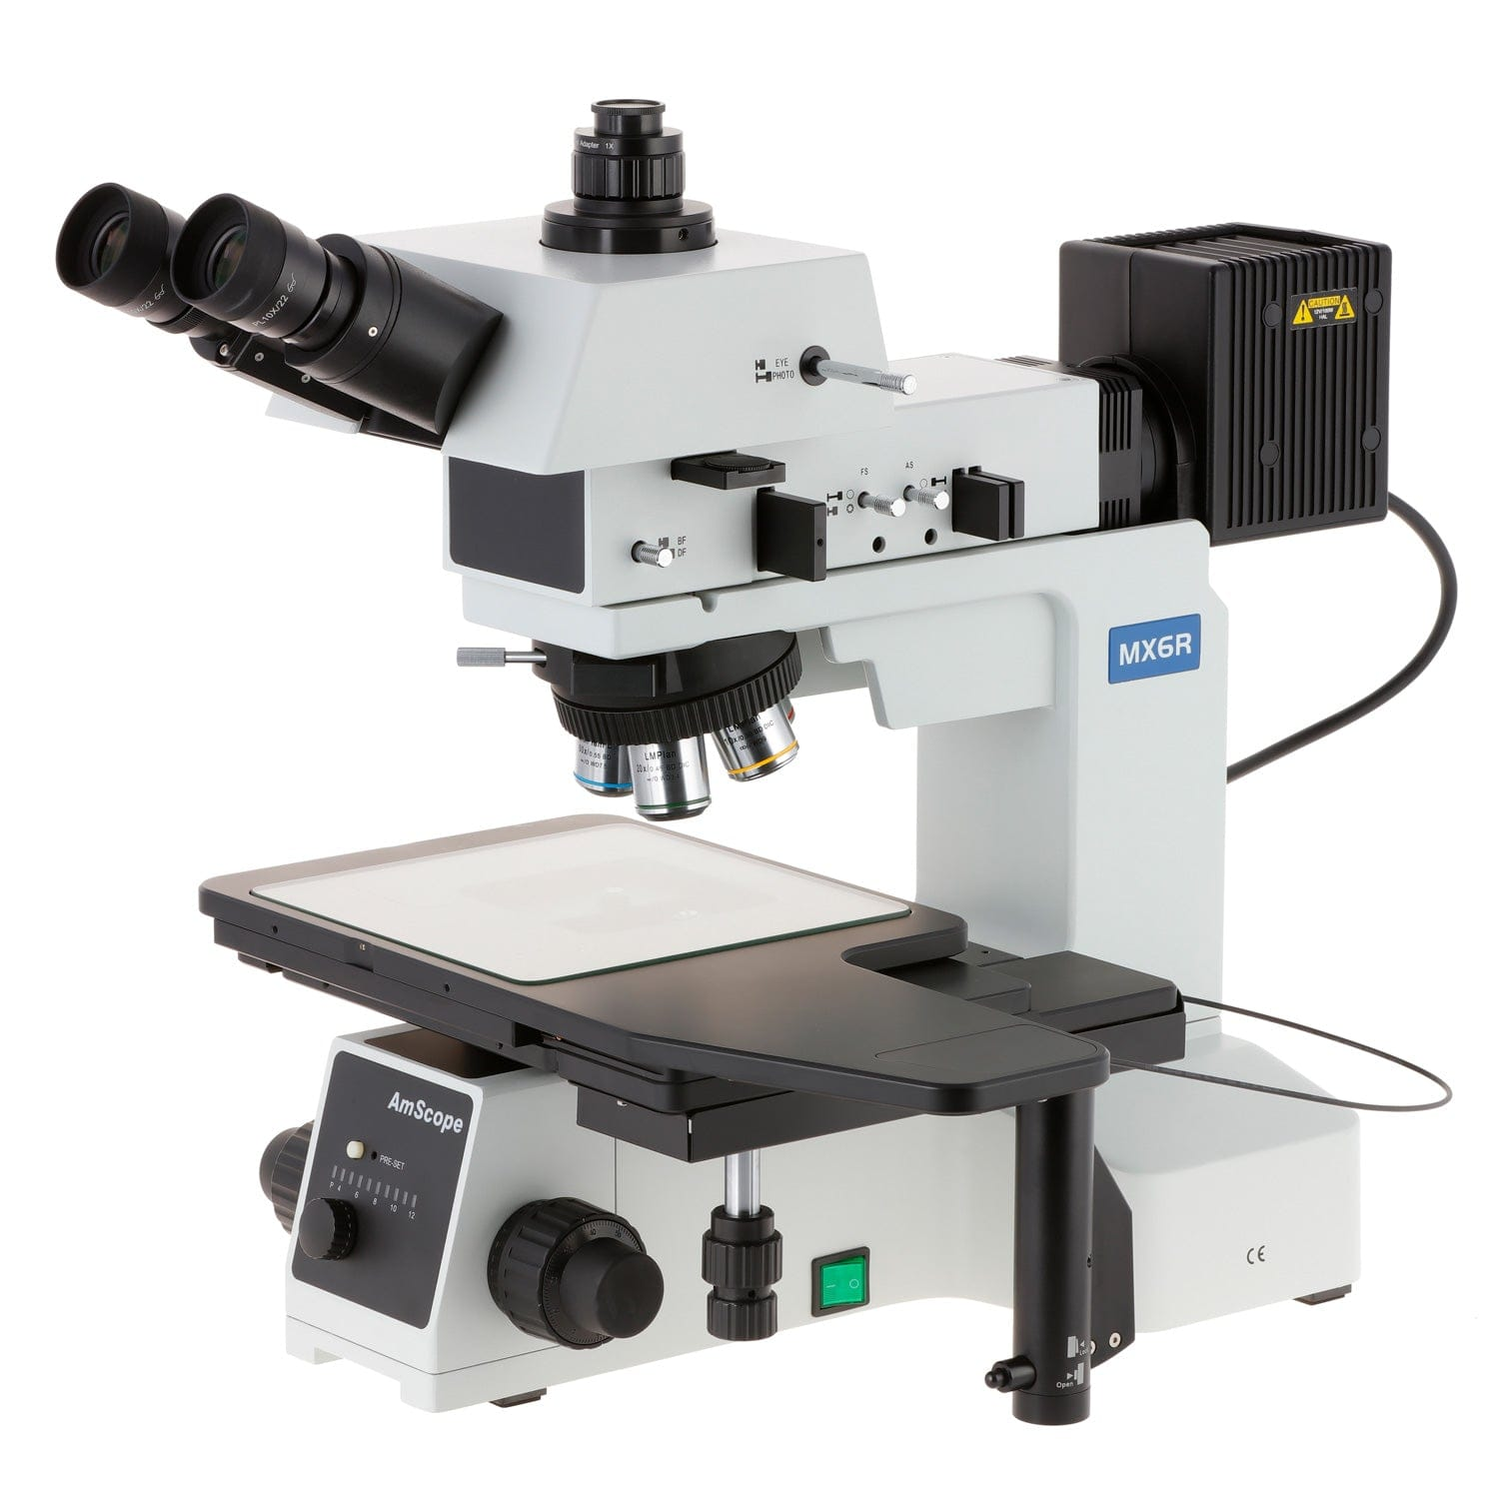

Large-Format Stage Trinocular Brightfield, Darkfield and Polarizing Metallurgical Microscope w/Optional Digital Camera

Sku: ME600T

~~$11,193.99~~$9,327.99

[VIEW PRODUCT](https://amscope.com/products/c-me600t?pr_prod_strat=collection_fallback&pr_rec_id=021533a00&pr_rec_pid=6856931213487&pr_ref_pid=6999684481199&pr_seq=uniform)

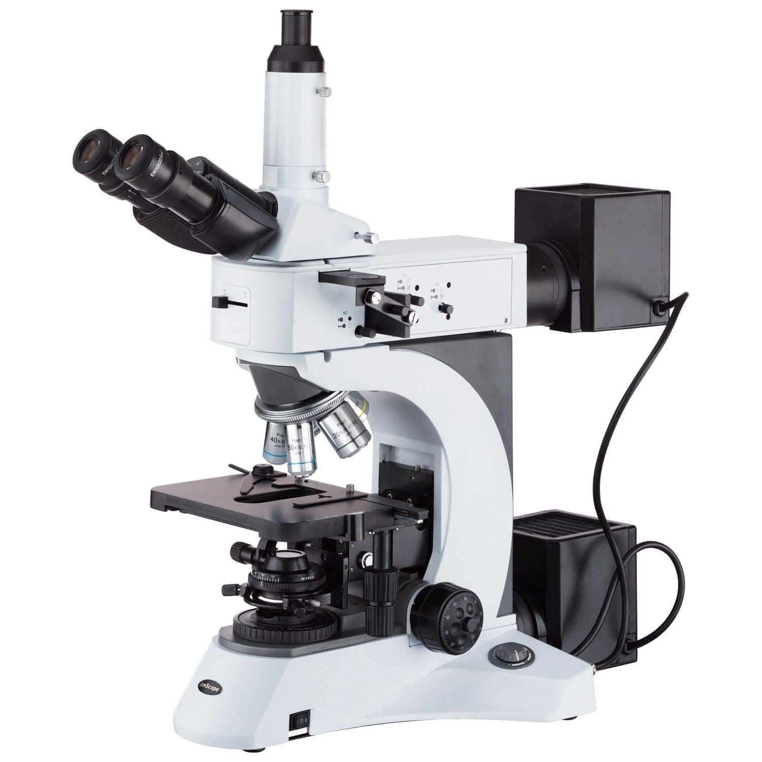

Trinocular Infinity-Corrected Darkfield Polarizing Metallurgical Microscope w/Optional HDMI Digital Camera

Sku: ME520T-HD2

~~$5,140.99~~$4,393.99

[VIEW PRODUCT](https://amscope.com/products/c-me520t-hd?pr_prod_strat=collection_fallback&pr_rec_id=021533a00&pr_rec_pid=7083018879151&pr_ref_pid=6999684481199&pr_seq=uniform)

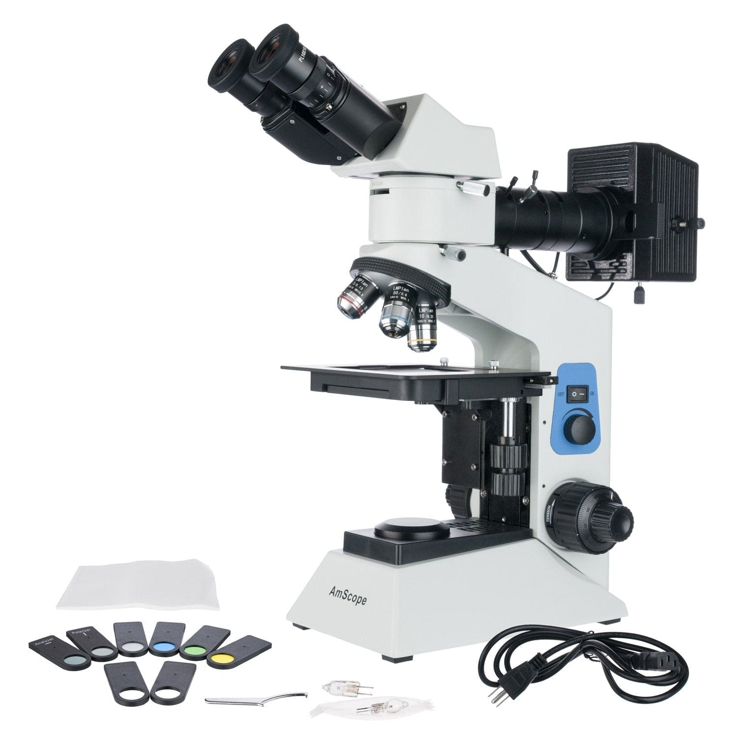

Dual Illumination Binocular Polarized Light Metallurgical Microscope w/Optional Digital Camera

Sku: ME580B-PZ

~~$1,096.99~~$913.99

[VIEW PRODUCT](https://amscope.com/products/c-me580b-pz?pr_prod_strat=collection_fallback&pr_rec_id=021533a00&pr_rec_pid=7083018846383&pr_ref_pid=6999684481199&pr_seq=uniform)

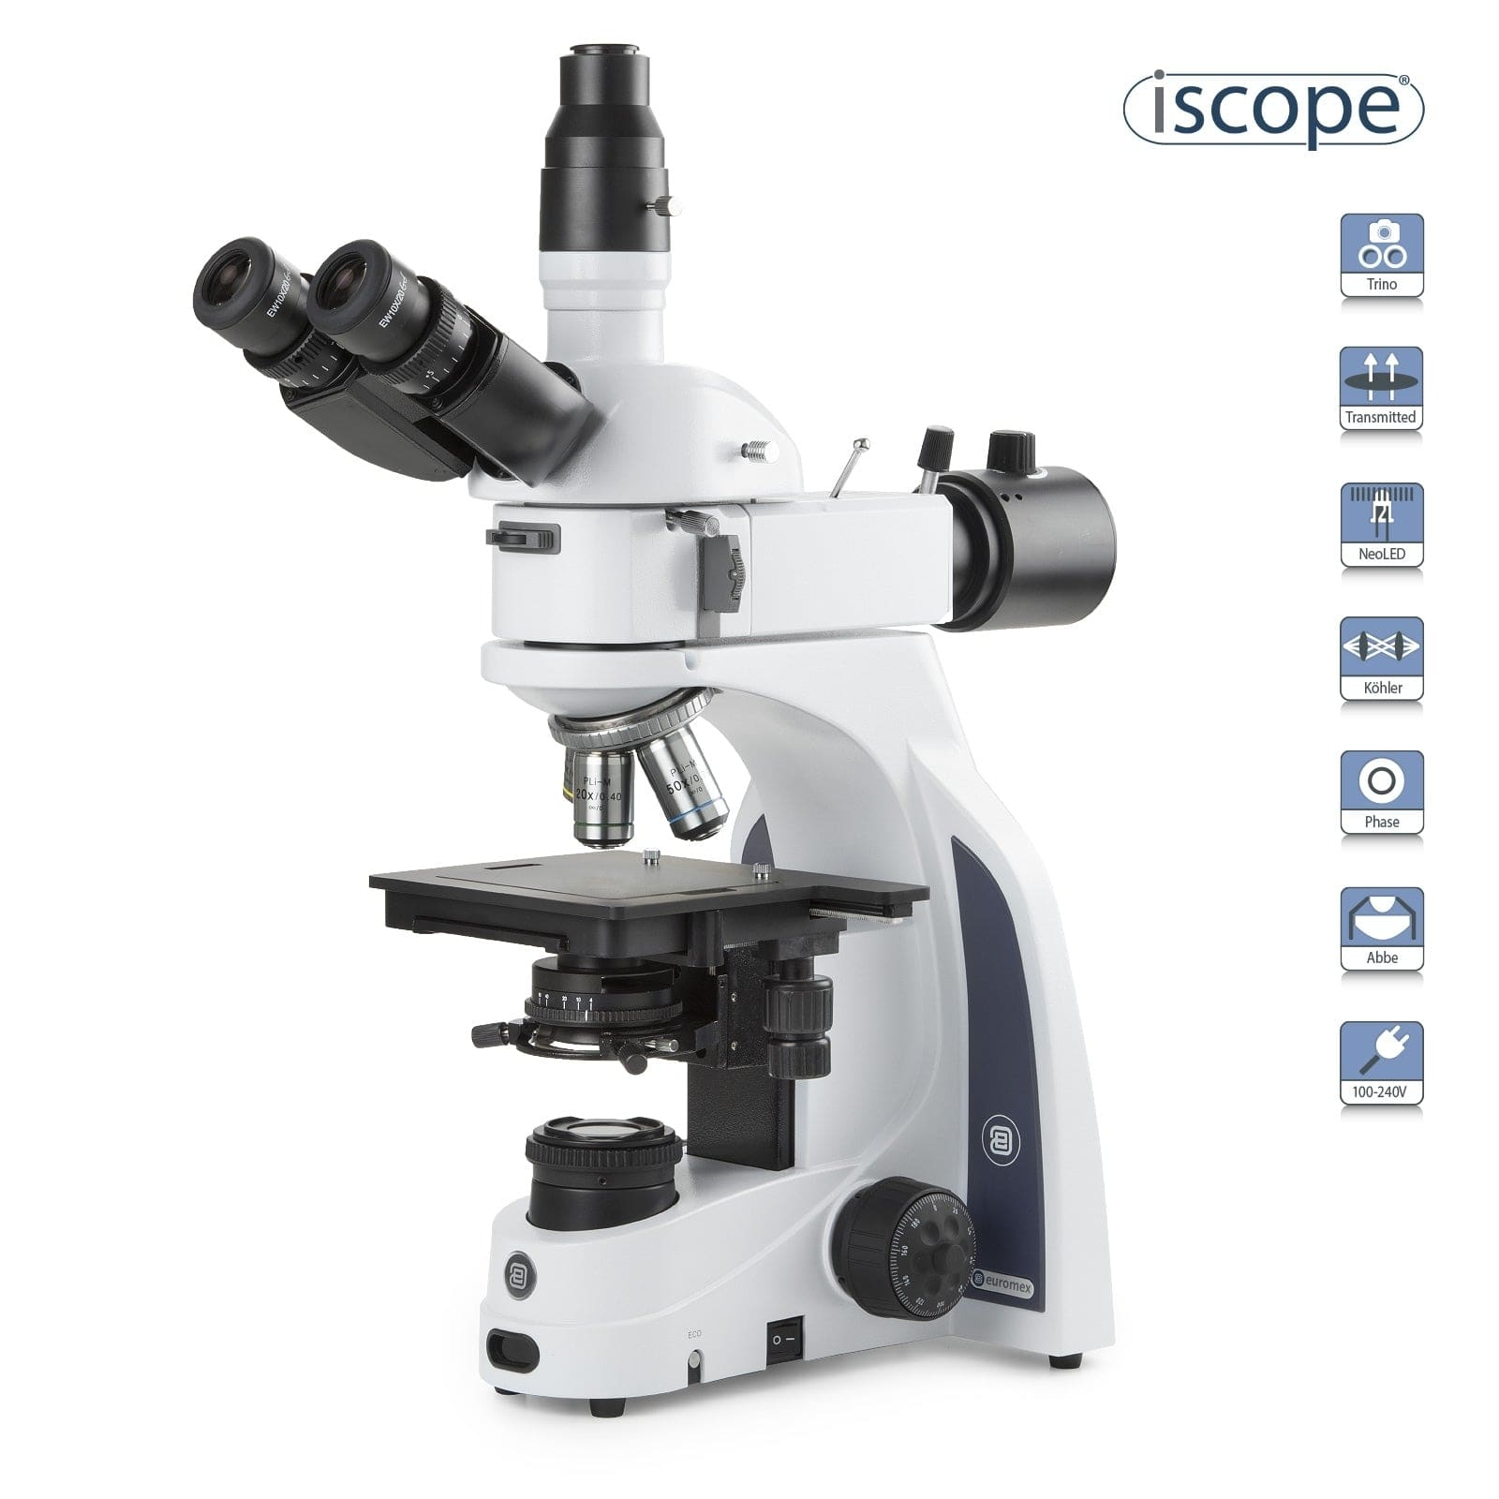

iScope Trinocular Materials and Metallurgy Compound Microscope

Sku: IS1053-PLMI

~~$3,828.99~~$3,190.99

[VIEW PRODUCT](https://amscope.com/products/c-is1053-plmi?pr_prod_strat=collection_fallback&pr_rec_id=021533a00&pr_rec_pid=6929943199919&pr_ref_pid=6999684481199&pr_seq=uniform)

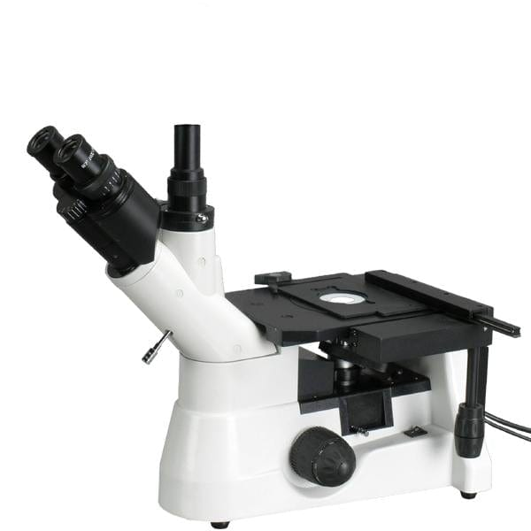

Trinocular Inverted Plan Optics Infinity-Corrected Polarizing Metallurgical Microscope w/Optional Digital Camera

Sku: ME1400T-INF

~~$1,726.99~~$1,475.99

[VIEW PRODUCT](https://amscope.com/products/c-me1400t-inf?pr_prod_strat=collection_fallback&pr_rec_id=021533a00&pr_rec_pid=7083018485935&pr_ref_pid=6999684481199&pr_seq=uniform)

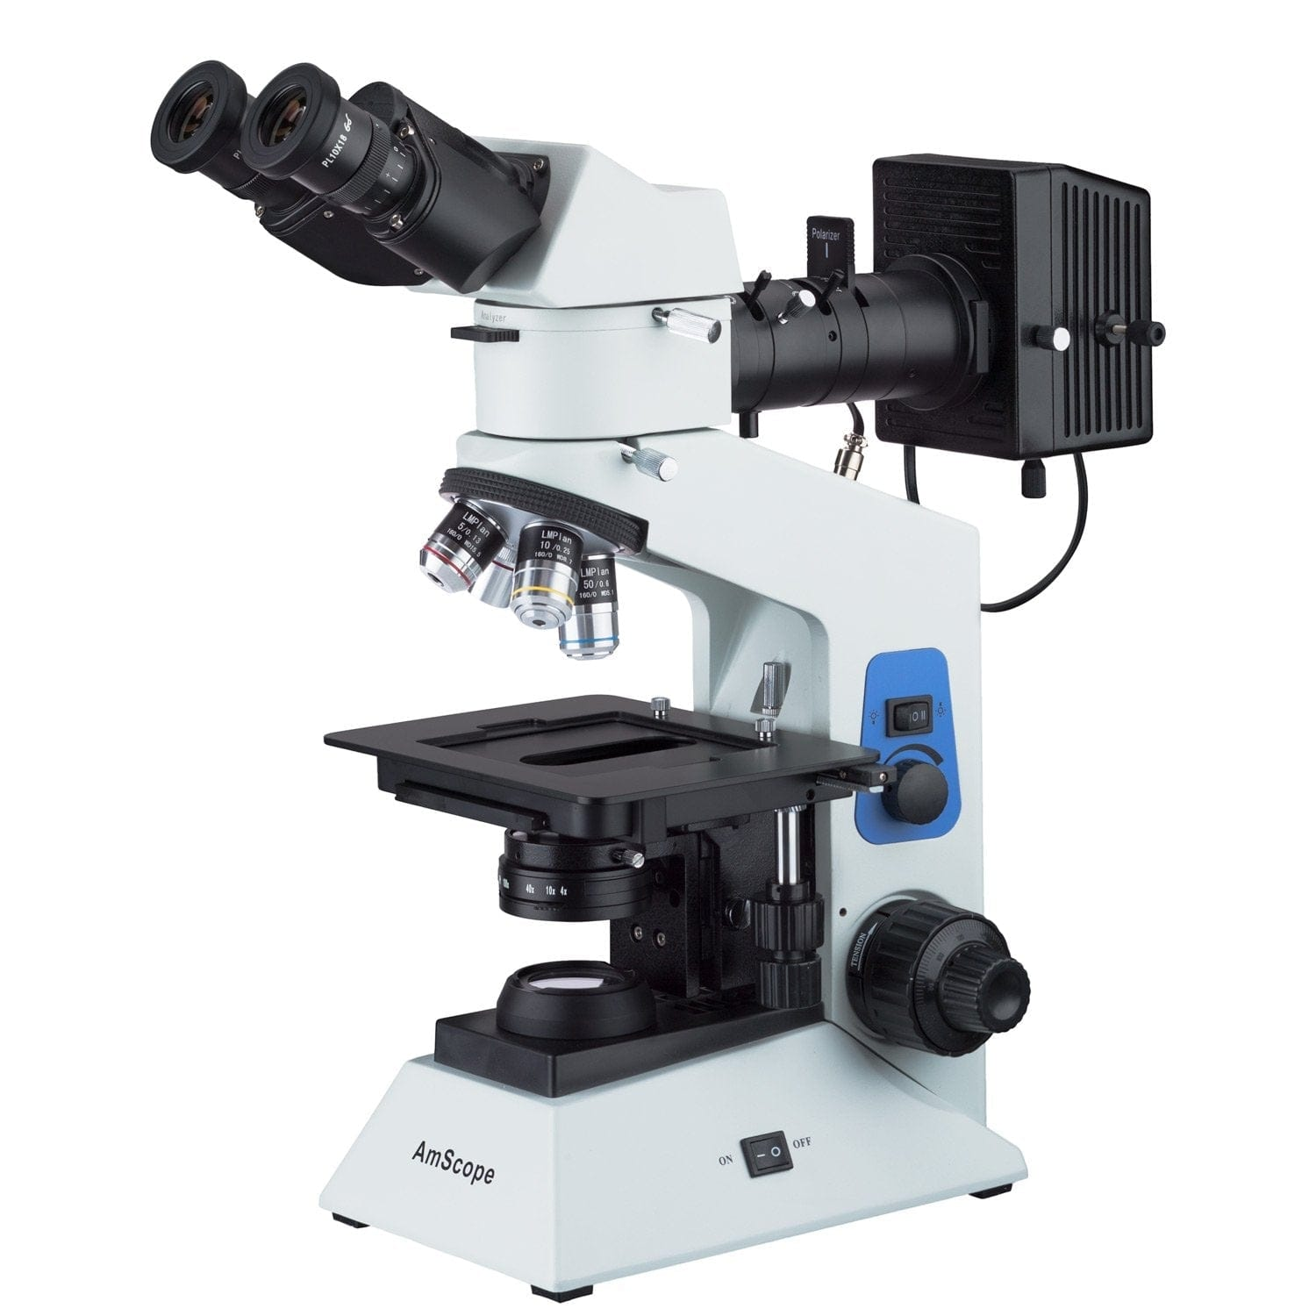

Compact Dual Illumination Polarized Light Binocular Metallurgical Microscope w/Optional Digital Camera

Sku: ME580B-PZ-2L

~~$1,147.99~~$956.99

[VIEW PRODUCT](https://amscope.com/products/c-me580b-pz-2l?pr_prod_strat=collection_fallback&pr_rec_id=021533a00&pr_rec_pid=7083018911919&pr_ref_pid=6999684481199&pr_seq=uniform)



Trinocular Inverted Plan Optics Polarizing Metallurgical Microscope w/Optional Digital Camera

Sku: ME1400T

~~$1,486.99~~$1,270.99

[Skip to Content](https://amscope.com/collections/metallurgical-microscopes/products/c-me600tz?variant=40841859661999" \l "acsbContent)

[↵ENTER](https://amscope.com/collections/metallurgical-microscopes/products/c-me600tz?variant=40841859661999" \l "acsbContent)

[Skip to content](https://amscope.com/collections/metallurgical-microscopes/products/c-me600tz?variant=40841859661999#MainContent)

0

[[https://cdn.shopify.com/s/files/1/0526/7285/6239/files/thumbnail_Clearance-sale-60off-US-top-ad_300x.jpg?v=1672993653](https://amscope.com/collections/blowout-clearance-sale-up-to-60-off)](https://amscope.com/collections/blowout-clearance-sale-up-to-60-off)

1. [Home](https://amscope.com/) /
2. [Metallurgical Microscopes](https://amscope.com/collections/metallurgical-microscopes) /
3. Large-Format Stage Trinocular Brightfield and Polarizing Metallurgical Microscope w/Additional 100X Objective Lens and Optional Digital Camera



50X-2500X Large-format Trinocular Upright Metallurgical Microscope w/ 20MP USB 3.0 C-mount Camera

Top of Form

SKU: ME600TZC-20MBI3

0.0 star ratingWrite a review

QTY:

−+

ADD TO CART

AVAILABILITY: IN STOCK

Regular price~~$13,804.99~~ $11,503.99

[**>> How to Buy A Microscope**](https://amscope.com/collections/metallurgical-microscopes/products/c-me600tz?variant=40841859661999#guide)

**Magnification**

50X-1000X

50X-1500X

50X-2000X

50X-2500X

**Camera Type**

none selected

USB 2.0

USB 3.0

**Camera Pixels**

3.0MP

5.0MP

10.0MP

14.0MP

16.0MP

18.0MP

20.0MP



Bottom of Form

Key Features

* 50X to 2500X magnification with five brightfield/darkfield objective lenses and 10X and 25X eyepieces.
* Designed for manufacturing, QC, and materials analysis, this large format microscope provides multiple observation methods including brightfield, darkfield, and simple polarization.
* Extra-large stage with clutch control for coarse positioning, and precision X-Y controls for microscopic adjustments
* Five large-diameter, plan-achromatic BD objective lenses provide increased field-of-view and high resolutions.
* Use a combination of brightfield, darkfield, and simple polarization to bring out complex details such as stress in metal and other materials.
* The infinity-corrected optical system eliminates certain optical errors when using filters and other in-line components, ensuring highly-precise images.
* The trinocular head provides a dedicated photo port for adding a camera for recording photos and videos.
* Monitor and capture photos and videos with the included back-illuminated 20MP USB 3.0 camera. Professional microscopy software for Windows, Mac, and Linux provide tools for image processing, measuring, and more.

DESCRIPTION

ADDITIONAL INFO

REVIEWS

0.0 star rating0 Reviews

WRITE A REVIEW

Top of Form

Bottom of Form

Top of Form

Bottom of Form

BE THE FIRST TO WRITE A REVIEW

People Also Viewed



Dual Illumination Polarized Light Compact Trinocular Metallurgical Microscope w/Optional Digital Camera

Sku: ME580T-PZ-2L

~~$1,193.99~~$994.99

[VIEW PRODUCT](https://amscope.com/products/c-me580t-pz-2l?pr_prod_strat=collection_fallback&pr_rec_id=021533a00&pr_rec_pid=7083019042991&pr_ref_pid=6999684481199&pr_seq=uniform)



Binocular Inverted Plan Optics Metallurgical Microscope w/Optional Digital Camera

Sku: ME1200T

~~$1,993.99~~$1,661.99

[VIEW PRODUCT](https://amscope.com/products/c-me1200t?pr_prod_strat=collection_fallback&pr_rec_id=021533a00&pr_rec_pid=7083018649775&pr_ref_pid=6999684481199&pr_seq=uniform)



Trinocular Metallurgical Microscope

Sku: ME300TZ

~~$1,098.99~~$915.99

[VIEW PRODUCT](https://amscope.com/products/c-me300tz?pr_prod_strat=collection_fallback&pr_rec_id=021533a00&pr_rec_pid=7083018453167&pr_ref_pid=6999684481199&pr_seq=uniform)



Large-Format Stage Trinocular Brightfield, Darkfield and Polarizing Metallurgical Microscope w/Optional Digital Camera

Sku: ME600T

~~$11,193.99~~$9,327.99

[VIEW PRODUCT](https://amscope.com/products/c-me600t?pr_prod_strat=collection_fallback&pr_rec_id=021533a00&pr_rec_pid=6856931213487&pr_ref_pid=6999684481199&pr_seq=uniform)



Trinocular Infinity-Corrected Darkfield Polarizing Metallurgical Microscope w/Optional HDMI Digital Camera

Sku: ME520T-HD2

~~$5,140.99~~$4,393.99

[VIEW PRODUCT](https://amscope.com/products/c-me520t-hd?pr_prod_strat=collection_fallback&pr_rec_id=021533a00&pr_rec_pid=7083018879151&pr_ref_pid=6999684481199&pr_seq=uniform)



Dual Illumination Binocular Polarized Light Metallurgical Microscope w/Optional Digital Camera

Sku: ME580B-PZ

~~$1,096.99~~$913.99

[VIEW PRODUCT](https://amscope.com/products/c-me580b-pz?pr_prod_strat=collection_fallback&pr_rec_id=021533a00&pr_rec_pid=7083018846383&pr_ref_pid=6999684481199&pr_seq=uniform)



iScope Trinocular Materials and Metallurgy Compound Microscope

Sku: IS1053-PLMI

~~$3,828.99~~$3,190.99

[VIEW PRODUCT](https://amscope.com/products/c-is1053-plmi?pr_prod_strat=collection_fallback&pr_rec_id=021533a00&pr_rec_pid=6929943199919&pr_ref_pid=6999684481199&pr_seq=uniform)



Trinocular Inverted Plan Optics Infinity-Corrected Polarizing Metallurgical Microscope w/Optional Digital Camera

Sku: ME1400T-INF

~~$1,726.99~~$1,475.99

[VIEW PRODUCT](https://amscope.com/products/c-me1400t-inf?pr_prod_strat=collection_fallback&pr_rec_id=021533a00&pr_rec_pid=7083018485935&pr_ref_pid=6999684481199&pr_seq=uniform)



Compact Dual Illumination Polarized Light Binocular Metallurgical Microscope w/Optional Digital Camera

Sku: ME580B-PZ-2L

~~$1,147.99~~$956.99

[VIEW PRODUCT](https://amscope.com/products/c-me580b-pz-2l?pr_prod_strat=collection_fallback&pr_rec_id=021533a00&pr_rec_pid=7083018911919&pr_ref_pid=6999684481199&pr_seq=uniform)



Trinocular Inverted Plan Optics Polarizing Metallurgical Microscope w/Optional Digital Camera

Sku: ME1400T

~~$1,486.99~~$1,270.99

[VIEW PRODUCT](https://amscope.com/products/c-me1400t?pr_prod_strat=collection_fallback&pr_rec_id=021533a00&pr_rec_pid=7083018584239&pr_ref_pid=6999684481199&pr_seq=uniform)

Free shipping on orders over $75

Easy 30 Day Returns

Quality Products

Do you have a question?

Sign up today and get 10% off your next purchase!

Top of Form

Email:

Bottom of Form

Customer Support

* [Help](https://amscope.com/pages/frequently-asked-questions)
* [Technical Support](https://amscope.com/pages/technical-support)
* [Camera Software Download](https://amscope.com/pages/software-downloads)
* [Manual Download](https://amscope.com/pages/manual-downloads)

Information Center

* [AmScope Business](https://amscope.com/pages/business)
* [Shop By Industry](https://amscope.com/pages/shop-by-industry)
* [Choosing a Microscope](https://amscope.com/pages/how-to-choose-microscope)
* [Using a Microscope](https://amscope.com/pages/how-to-use-microscope)
* [Microscope Parts and Functions](https://amscope.com/pages/microscope-parts-and-functions)
* [Educational Resources](https://amscope.com/pages/educational-resources)
* [Blog](https://amscope.com/blogs/news)

My Account

* [Create A New Account](https://amscope.com/account/register)
* [View Cart](https://amscope.com/cart)
* [My Account](https://amscope.com/account)
* [Reseller Program](https://amscope.com/pages/reseller-program)

Company

* [About Us](https://amscope.com/pages/about-us)
* [Terms & Conditions](https://amscope.com/pages/terms-conditions)
* [Refund Policy](https://amscope.com/policies/refund-policy)
* [Privacy](https://amscope.com/pages/privacy-policy)
* [Do not sell my personal information](https://amscope.com/pages/ccpa-opt-out)
* [Contact Us](https://amscope.com/pages/contact-us)
* [Our Customers](https://amscope.com/pages/customer-list)

Follow Us

* [Facebook](https://www.facebook.com/Amscope)

* [Instagram](https://www.instagram.com/amscope_/)

* [YouTube](https://www.youtube.com/user/Amscopecom)

* [LinkedIn](https://www.linkedin.com/showcase/amscope/)

© 2023 AmScope. All Rights Reserved.

1. X-ray Crystallography equipment
2. **Electron microscope - Ultra-High Resolution Analytical FESEM SU7000**

Top of Form

Bottom of Form

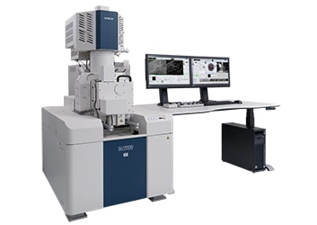

**SU7000: The Next-Generation FE-SEM**

The modern FE-SEM requires not only high performance but also a multitude of functionalities including wide-area observation, in-situ analysis, variable pressure, high-resolution imaging at low accelerating voltages, and simultaneous multi-signal collection.

The SU7000 is designed to address these aspects and more by delivering enhanced information for diversified needs in the field of electron microscopy.

**Specifications**

|  |  |  |  |
| --- | --- | --- | --- |
| Image Resolution | Resolution SE | | 0.8 nm@15 kV |
| 0.9 nm@1 kV |
| Magnification | | | 20～2,000,000 x |
| Electron Optics | Emitter | | ZrO/W Schottky Emitter |
| Accelerating Voltage | | 0.1～30 kV (0.01 kV step) |
| Probe Current | | Max. 200 nA |
| Detectors | Standard Detectors | | UD（Upper Detector) |
| MD（Middle Detector） |
| LD（Lower Detector) |
| Optional Detectors | | PD-BSED（Semiconductor type） |
| UVD (Ultra Variable Pressure Detector） |
| Variable Pressure(VP) Mode (Option) | Pressure Range | | 5～300 Pa |
| Available Detectors in VP mode | | PD-BSED, UVD, UD, MD,LD |
| Specimen Stage | Stage Control | | 5-axis Motor Drive |
| Movable Range | X | 0～135 mm |
| Y | 0～100 mm |
| Z | 1.5～40 mm |
| T | -5～70° |
| R | 360° |
| Specimen Chamber | Specimen Size | | Max. φ200 mm, Max. 80mm Height |
| Monitor（Option) | | | 23 inch LCD（1,920×1,080) , supports dual monitors operation |
| Image Display Mode | Large Screen Display Mode | | 1,280×960 pixels |
| Single Image Display Mode | | 800×600 pixels |
| Dual Image Display Mode | | 800×600 pixels、1,280×960 pixels with dual monitors |
| Quad Image Display Mode | | 640×480 pixels |
| Hex Image Display Mode w/dual monitors | | 640×480 pixels with dual monitors |
| Image Data Saving | Pixel Size | | 640×480、1,280×960、2,560×1,920、5,120×3,840、10,240×7,680 |
| Optional Accessories | Energy Dispersive X-ray Spectrometer (EDX) | | |
| Wavelength Dispersive X-ray Spectrometer (WDX) | | |
| Electron Backscattered Diffraction Detector (EBSD) | | |
| Cathodoluminescence System (CL) | | |
| Cryogenic Transfer System | | |
| Compatible with various types of sub-stages | | |

**MECHANICS OF MACHINES LABORATORY EQUIPMENT**

1. **Static and Dynamic Balancing Systems**
2. **Quick return mechanism s (Withworth), Scotted Line Slider-Crank, Scoth yoke Geneva stop**
3. **Free Oscillation of point and distributed masses (Simple and Compound Pendulum)**

WORKSHOP EQUIPMENT

FITTINGS & MACHINING SECTION

1. CNC Lathe Machine
2. CNC Milling Machine
3. Folding Machine
4. Power Hacksaw

WELDING & FABRICATION SECTION

1. Arc Welding Machines and Accessories
2. Guillotine cutting Machine
3. Rolling Machine